INSERT YOUR CLUB LOGO HERE
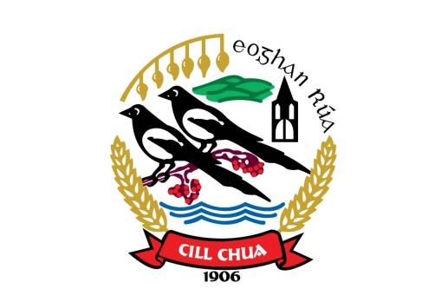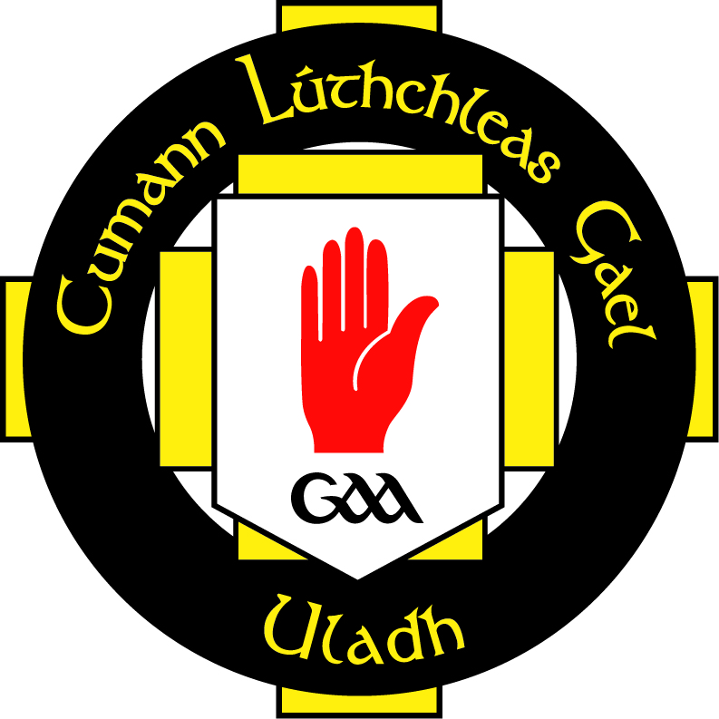
VALUING VOLUNTEERS POLICY

Kilcoo GAC recognises the valuable input of volunteers to our club. We commit to supporting our volunteers in their role by following recommendations made by our governing body of sport that stipulate our volunteers should under-go a recruitment process. The following procedures for recruitment of volunteers will assist in placing volunteers in a situation to which they are suited and help in the protection of children and volunteers alike.
- List all tasks that volunteers need to perform and the skills needed for those tasks
- Provide training for volunteers in their role by urging them to attend Ulster GAA Club Maith Officer Training Programme
- Make vacancies within the club openly available to interested and qualified applicants
- An application from should be completed by each applicant
- There may be need for new coaches who have substantial access to children regardless of whether they are paid or not, to have their background checked.
- References should be verified by the Club Executive Committee and should be kept on file for record
- All recommendations for member appointment should be ratified by the club’s Executive Committee. The decision to appoint team managers is the responsibility for the club Committee and not any one individual within it.
- Once recruited into the club, all volunteers should be adequately managed and supported
- Any statutory guidelines should be adhered to

This document has been approved by the Club Executive Committee and serves as the working recruitment policy document of Kilcoo GAC.

Signed __________________________________________ Date __________________________
Rúnaí

Signed __________________________________________ Date __________________________
Cathaoirleach

