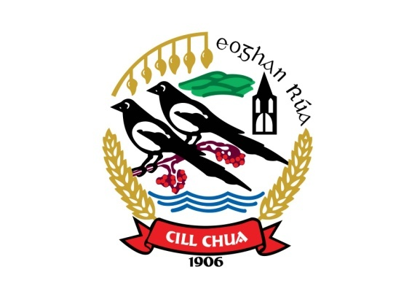

Non-playing Members Code of Conduct

Kilcoo GAC adapts a child centred approach and philosophy in the running of the club to ensure that those working with children and young people are at all times provided a quality sporting and social programme, by working to an agreed philosophy and set of standards. Enforcement of this conduct is the responsibility of every member and any queries about this code should be referred to the Children’s Officer or the Club Chairperson

All parents must:
- Respect the rights, dignity and worth of all and treated everyone equably.
- Not exert undue influence to obtain personal benefit or reward.

Administrators within the club must:

  - Make your club environment more user friendly by providing equal opportunities for all to participate.

  - Create pathways for young people to participate in Gaelic Games not just as a player, e.g. as a referee coach administrator etc.

  - Ensure that the types of programmes, rules, equipment length of games and training schedules are modified to suit the age ability and maturity level of young players.

  - Provide quality supervision and instruction for junior players and ensure volunteers are adequately trained.

  - Direct coaches and officials to highlight behaviour and skill development.

  - Ensure that everyone emphasises fair play, not winning at all costs.

  - Give a code of behaviour sheet to spectators, parents and coaches and players and encourage them to follow it.

  - Remember you set an example. Your behaviour and comments should be positive and supportive.

  - Maximise child safety by conducting volunteer screening and other child protection strategies.

  - Implement Policy and practices (and lead by example) in relation to responsible use of alcohols and in relation to recreational and performance enhancing drugs.

  - Adopt and implement relevant sports safety policies and practices.

  - Promote a culturally tolerant environment.

  - Listen to your players and involve them in the decision leadership and planning and evaluation relation to the club.

  - Respect the rights, dignity and worth of all participants regardless of their gender, ability and cultural background or religion.

I understand and agree to abide by this Code of Conduct. I understand that failure to abide by this Code of Conduct will result in disciplinary action by the Club Executive Committee.

Signed:______________________________________

Date:________________________________________

Countersigned_____________________________________
Children’s Officer

