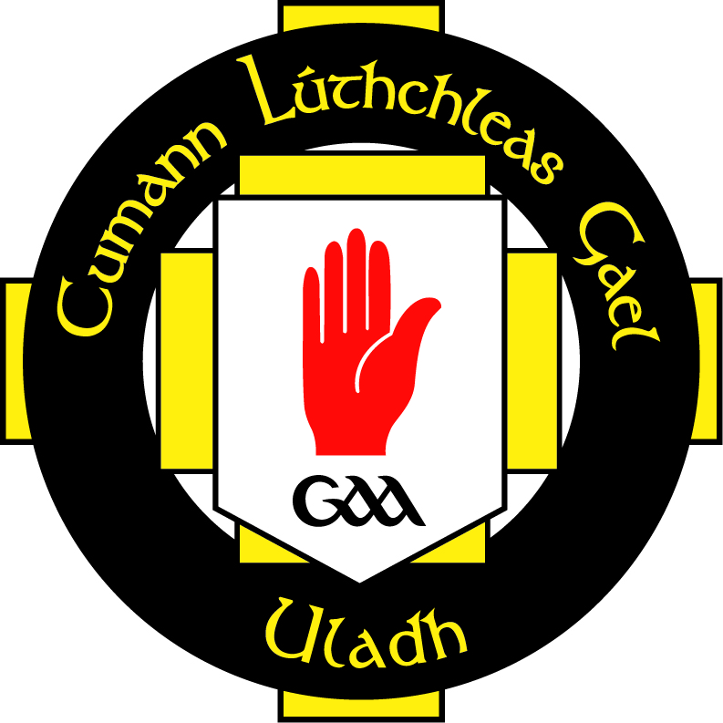

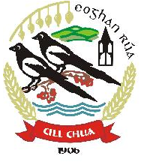

GAMES FOR ALL POLICY

Kilcoo GAC recognises that as Gaelic games are a major facet of the GAA club, opportunities to play Gaelic games should be available to all people within the community. Such opportunities will offer greater quality of experience for past, present and future club members.

Our club Games for All policy reflects the agenda driven by Down County Board, Ulster GAA and National GAA.

In order to implement a Games For All policy our club will strive to:

- Recognise the importance in affording equal opportunities and fair treatment to all its members and potential members

- Ensure participation opportunities for all people irrespective of age, gender, ability, race, religion, ethnic origin, creed, colour, nationality, social status or sexual orientation. Participation opportunities include all elements of Gaelic Games including as a player, coach, manager, match official, administrator or spectator.

- Actively seek to include “others” in our games by implementing such schemes as “Have A Go Days”, “Recreational GAA”, “Including People with Disabilities” and others that may been advantageous in encouraging people from under-represented groups to become involved in club activity.

- Treat all members, employees, job applicants and provision of facilities equally.

- Eliminate perceived barriers to participation which discriminate against particular groups or individuals

- Provide an opportunity for all members, volunteers and officials within the club to attend Equality Training, Disability Awareness Training and any other training which will help the club improve its outreach work.

The club expects all those acting on behalf of the Association to adhere to this policy. In pursuance of this policy the Club Executive Committee reserve the right to discipline any of its members or employees who practice any form of discrimination on the grounds of a person’s age, gender, ability, race, religion, ethnic origin, creed, nationality, social status or sexual orientation.

This document has been approved by the Club Executive Committee and serves as the working Games For All policy of Kilcoo GAC

Signed: __________________________________________ Date: __________________
Cathaoirleach

Signed: __________________________________________ Date: __________________
Rúnaí

