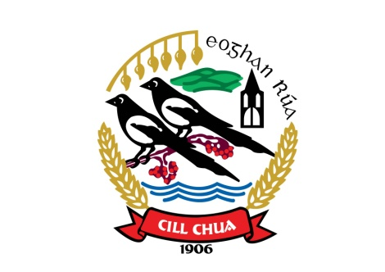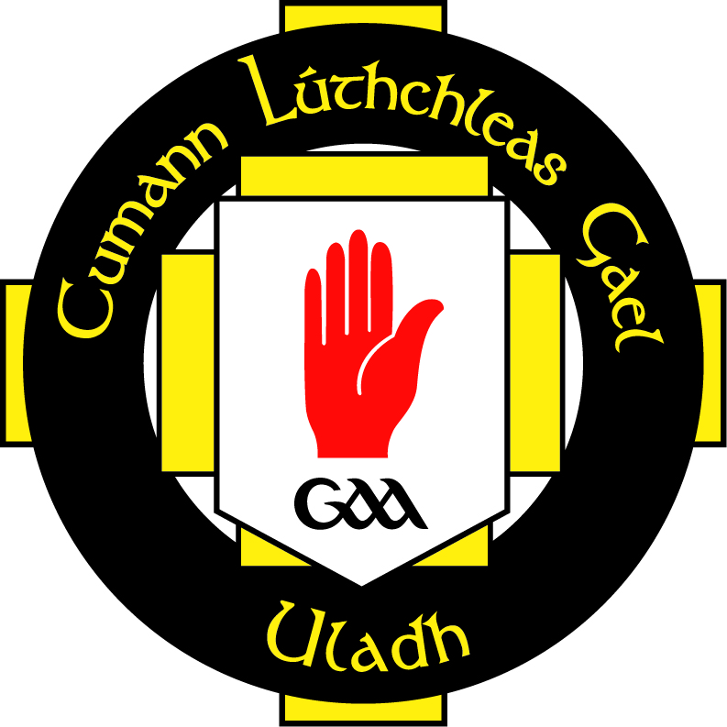

Disability & Special Needs Policy
Kilcoo GAC is committed to the inclusion of all persons with a physical or mental impairment that has a substantial and long-term adverse effect on a person's ability to carry out normal day-to-day activities, from here on referred to as a disability.
This policy should be read in conjunction with the Club Equality Policy
As such our club will:
- Provide a welcoming and open atmosphere for disabled club members
- Provide a programme of activities for disabled club members
- Ensure that all club facilities are disability friendly and adhere to the relevant legislation in reference to disabled access.
- Ensure club facilities are open to use by Special Schools or other community groups who cater for persons with a disability
- Attend UIster GAA CPD courses on disability, special needs and the promotion of disabled games
- Provide a programme of disabled games in conjunction with other local GAA clubs in the area
- Ensure that positive images and role models of disabled people and disabled coaches will be represented in all resources, promotional and publicity material
- Appoint a Executive Level officer with responsibility for linking with special schools and catering for members with disabilities
- Share good practice with other GAA/Sports Clubs
- Develop links with other sporting clubs through the Local Sports Council/Partnership to cater for disabled members
- Link with relevant statutory bodies in the area of disability

Monitoring and Evaluation
A comprehensive monitoring and evaluation system will be developed to ensure the successful implementation of the disability policy. A report will be given to the club executive committee on a regular basis with an overall report given at the Club Annual General Meeting.

Signed____________________________________
Secretary

Signed____________________________________
Equality Officer

