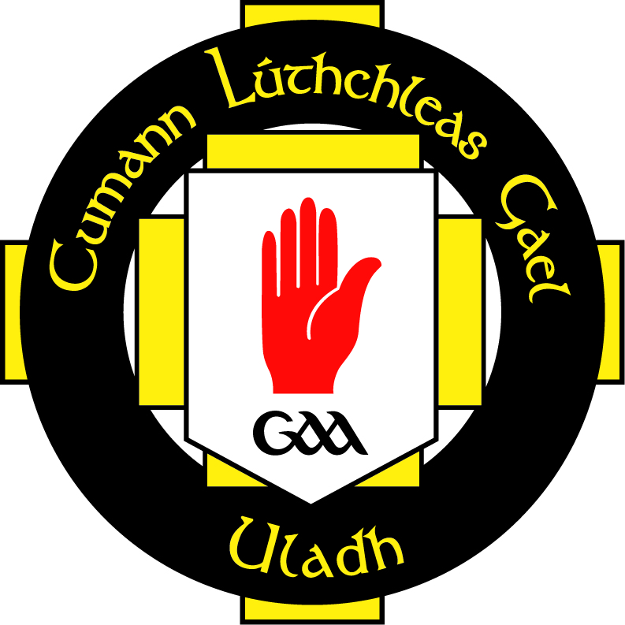

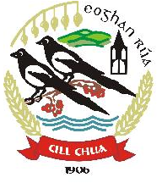

Coaches Code of Conduct

Kilcoo GAC adapts a child centred approach and philosophy in the running of the club to ensure that those working with children and young people are at all times provided a quality sporting and social programme, by working to an agreed philosophy and set of standards. Enforcement of this conduct is the responsibility of every member and any queries about the code should be referred to the Child Protection Officer or Coaching Coordinator

All Members must:
- Respect the rights, dignity and worth of all and treat everyone equitably.
- Not exert influence to obtain personal benefit or reward

Coaches within the Club must:

  - Remember that young people participate for the pleasure and winning is only part of the fun. Place the well-being and safety of any juvenile above the development of performance and adhere to all guidelines laid down by the club and the GAA in general.

  - Give young people the chance to try out different playing positions.

  - Create opportunities for participants to learn appropriate sports behaviour as well as basic skills.

  - Give priority to free play activities, skill learning and small-sided games over highly structured competitions.

  - Ensure that activities are appropriate to the age, maturity and ability of the young player.

  - Keep up to date with the coaching practices and qualifications and the principles of physical growth and development. Take responsibility for ensuring training is kept up to date and keep abreast of any developments within the association.

  - Ensure that you are working at a level commensurate with your coaching qualifications

  - Promote a culturally tolerant environment.

  - Help young people understand that playing by the rules is their responsibly.

  - Always promote positive aspects of sport and never condone or participate in rules violation, bad sportsmanship, the use of foul and abusive language, the use of sectarian language and banter, the use of prohibited substances, the use of gestures or emblems which could be interpreted as provocative.

  - Encourage young people to participate in administration, coaching and referring as well as playing.

  - Operate within the rules and sport of the sports and teach your players to do the same.

  - Relate to officials in a courteous and polite way.

  - Ensure that any physical contact with a young person is appropriate to the situation and necessary for the player’s skill development.

  - Implement relevant sport safety policies and practices.

  - Arrive on time for all coaching sessions, competitions, social occasions and coaches must inform an appropriate person if they are unable to attend.

  - Encourage and guide young people to accept responsibility for their own behaviour and performance and encourage to young people to feel confident and comfortable in making person choices.

  - Ensure attendances records are kept of all recognised club sessions with the attendance of each participant noted appropriately. A club incident form must be used to record any accidents, injuries or untoward event.

  - Implement policy practices (and lead by example) in relation to responsible use of alcohol and in relations to recreational and performance enhancing drugs.

  - Listen to your players and ensure that the time they spend with you is a positive experience.

  - Respect the rights, dignity and worth of all participants regardless of their gender, ability, cultural background or religion.

Declaration

I understand and agree to abide by this Code of Conduct. I understand that failure to abide by this Code of Conduct will result in disciplinary action by the club committee.

Signed:______________________________________

Date:________________________________________

Signed_____________________________________
Coaching Officer

Signed_____________________________________
Child Protection Officer

